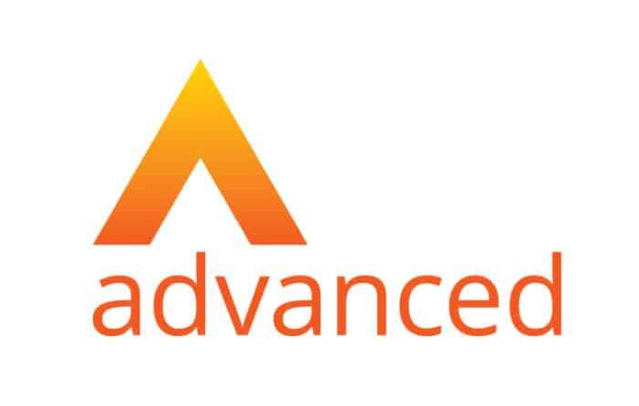
Most Inspirational Colleague in Repairs Award 2025 – sponsored by ONE Advanced
The Awards are free to enter and the closing date for receipt of completed applications is Tuesday 31st December 2024. Please send your submission to:
marketing@direct-works.co.uk
Your name
Name of organisation
Telephone
Email
Name of Person being nominated

Entry criteria
Please use video to make your submission, supported by a written statement offering more information on this form, below.
Your video should be:
- No longer than 2 minutes in length
- Capture the essence of your entry in line with the full criteria below
- Shared via viewable link included in this document to e.g. YouTube, Vimeo. Please do not make the video public until after the awards ceremony on 4th March 2025. Ensure you provide any access details we may require to view the video. You can also share via wetransfer (link or send the file to marketing@direct-works.co.uk
Your video does not need to be a Hollywood feature movie, and thus, does not need to be edited as such.

We intend to show the winner’s video on the night of the award. Please highlight any sensitive information which needs to be removed to the marketing team. You can also use the written section to record sensitive information.

Entries are open to members and / or affiliate members. We would particularly love to see you working in partnership and will reward joint entries.
The Most Inspirational Colleague in Repairs award celebrates those who uplift the workforce, fostering a supportive work environment. The nominee must demonstrate resilience, support colleagues, and lead by example. Your entry should include examples of this as well as, where possible:
- How the individual is recognised by peers for their dedication and motivation.
- List achievements or areas of strength.
- Include any evidence of ‘going the extra mile’ in delivering services, support or being an ambassador for their organisation.
- Include any references or compliments from colleagues, customers or other organisations with whom the individual works closely.

Please provide a short summary (no more than 50 words) of why you think this person should be considered, that can be published by Direct Works if your entry is shortlisted. Please attach a high-resolution JPEG photograph of the nominee along with this completed application via email to marketing@directworks.co.uk by Tuesday 31st December 2024.

Link to video:

Password (if required)

Considering the criteria above, please support your video entry with a written summary of no more than 500 words.

Link to supporting information (optional):

Password (if required):

