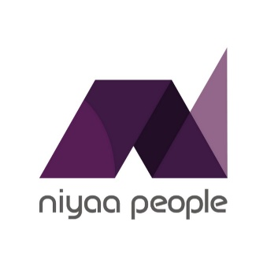
Outstanding Resident Engagement Award 2025 – sponsored by Niyaa People
The Awards are free to enter and the closing date for receipt of completed applications is Tuesday 31st December 2024. Please send your submission to:
marketing@direct-works.co.uk
Your name
Name of organisation
Telephone
Email
Entry Title

Entry criteria
Please use video to make your submission, supported by a written statement offering more information on this form, below.
Your video should be:
- No longer than 2 minutes in length
- Capture the essence of your entry in line with the full criteria below
- Shared via viewable link included in this document to e.g. YouTube, Vimeo. Please do not make the video public until after the awards ceremony on 4th March 2025. Ensure you provide any access details we may require to view the video. You can also share via wetransfer (link or send the file to marketing@direct-works.co.uk

Your video does not need to be a Hollywood feature movie, and thus, does not need to be edited as such.

We intend to show the winner’s video on the night of the award. Please highlight any sensitive information which needs to be removed to the marketing team. You can also use the 500 word written section for sensitive information.

Entries are open to members and affiliate members. We would particularly love to see you working in partnership and will reward joint entries.
Central to all our organisations is happy residents and resident engagement is a key aspect of social housing maintenance. For the Outstanding Resident Engagement award, we’re looking for projects that:
- Demonstrate exceptional communication and engagement with residents regarding repairs and maintenance.
- Shows evidence of improved resident satisfaction and service outcomes.
- Employs innovative methods to involve residents in the maintenance process.

Please provide a short summary (no more than 50 words) of why you think this entry should be considered, that can be published by Direct Works if your entry is shortlisted. Please attach a high-resolution JPEG photograph of the nominee along with this completed application via email to marketing@directworks.co.uk by Tuesday 31st December 2024.

Link to video:

Password (if required)

Considering the criteria above, please support your video entry with a written summary of no more than 500 words.

Link to supporting information (optional):

Password (if required):

